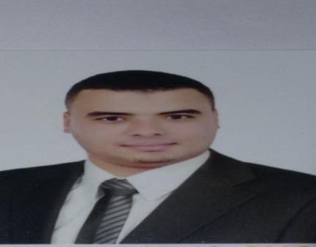

**Personal Information**

Full Name: Muhammed Mahmoud AboElgoud.

Mobile: +201148896403.

E-mail: mohgood2020@gmail.com.

Address: 3/4 Area 10th-District-Nasr-city, Cairo, Egypt.

Date of Birth: 3st June 1987.

Education: BSc of computers & information Mina University 2008 with 72% Percentage.

**Carrier Description**

I’m a Senior Software developer with 7 years experience designing, developing and deploying web application using a variety of skills. I have worked on many large scale projects from concept to completion, specialist in PHP from scratch, PHP Frameworks like Laravel, codeigniter and Lumen for web services.

I’m using Test Driven Development and Behavior Driven for Testing (PHPunit – Codeception - Behat).

I’m trying to learn and use latest technologies in my projects.

I’m trying to go on test automation using Jenkins as Example.

**Technical Skills**

* PHP7 /PHP5- MySQL- PostgreSQL and Oracle Database 10g.
* Laraval – Symfony - CodeIgniter and Lumen Frameworks.
* Web Services (Restful - GraphQL -JWT - PHPUnit -XML- JSON- SOAP- WSDL).
* WordPress - Joomla and Drupal CMSs.
* Bootstrap - CSS3 - JavaScript - Jquery and Ajax.
* NoSqL like MongoDB and CouchDB.
* Git Version Control (Bitbuket and Gitlab)- Agile using Jire.
* Third Party Integrations like Google Pay-fort, SendGrid.
* OOP – Design Patterns – MVC concepts.
* Angular and Nodejs (Socket IO).
* LAMP Stack (Linux-Apache-Mysql-PHP).
* Docker , AWS and Swagger Documentation.

**Personal Characteristic**

I suppose that I have the following points:

* Fast Learner
* Team worker
* Enthusiastic to learn new technologies.
* Working in parallel projects
* Interesting to meet timeline.
* Working in organized way.
* Planning tasks and projects.

**Working History**

Company Name***:*** RazyTech

Date: (From 4/2012 to 5/2014).

Job Title: PHP Developer.

Job Description

* Develop native PHP Projects.
* Produce CRM Reports.
* Build web Application.

Company Name***:*** Ebdaa Tech

Date: (From 6/2014 to 10/2016).

Job Title: Senior Backend Developer (act as team leader).

Job Description

* Develop web applications using PHP Frameworks.
* Build classified websites.
* Produce web services and APIs.
* Design new features and Database structure.

Company Name***:*** Minds Pool (Smart Way & GreenTech)

Date: (From 2016 to 2018).

Job Title: Senior Backend Developer.

Job Description

* Backend services for mobile applications.
* Act as a team player in some projects.
* Analysis’ new platforms for booking systems.
* Produce web services and APIs.
* Build new projects components.
* Refactoring projects using MVC.
* Build web educational services and LMS.

Company Name***:*** Afaqy <http://afaqy.com/>

Date: (From 2018 to Now).

Job Title: Senior Backend Developer.

Job Description

* Backend services for mobile applications.
* Act as a team player in some projects.
* Working on Tracking systems.
* Produce web services and APIs.
* Upgrading Old Platforms.
* Refactoring projects using MVC.
* Integrate with another services and Different systems.

**My Best work Portfolio**

* AVL for Tracking and Monitoring Vechiles (<https://avl.afaqy.sa/login>).
* Saudi Electronic University (<https://www.seu.edu.sa>).
* Booking Mobile Application (Duty) (<http://dutyapp.com>).
* School Management Systems.
* Cosmetics E-commerce Platform.
* CRM Online Application.
* MzadQater (<https://mzadqatar.com>).
* Learning Management System [(http://najeh.online)]((http:/najeh.online)).
* Twffer (<http://twffer.com>).
* Real Estate Web Sites.
* Servpedia Application (<https://www.servpedia.com>).